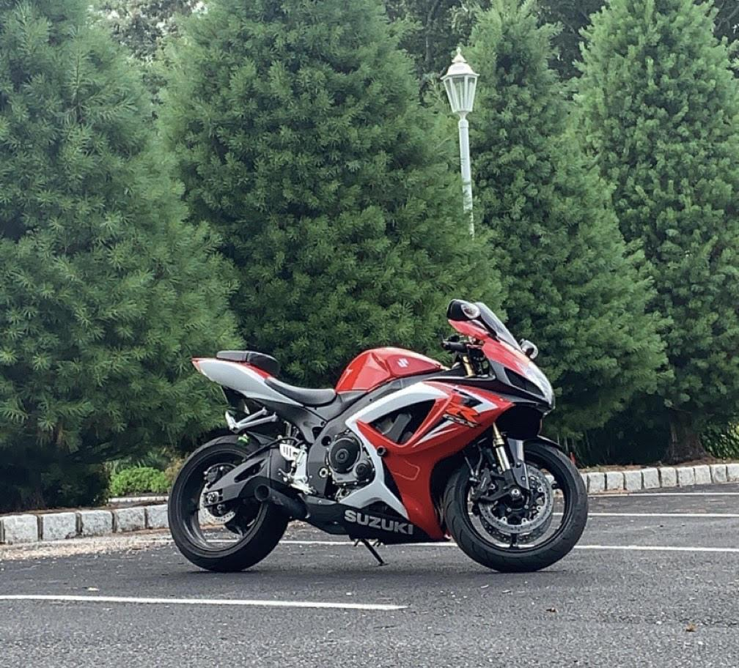

This may be an extremely difficult object to create, but I feel like trying to recreate my motorcycle would be a fun object and it would be really cool to see the finished product. Many primitive shapes are pretty easy on the motorcycle, Toruses for the wheels, cylinders for the exhaust as well as the forks. Utilizing multiple spheres it would be possible to create many parts of the body work. As well as using cones and pyramids to complete bodywork. 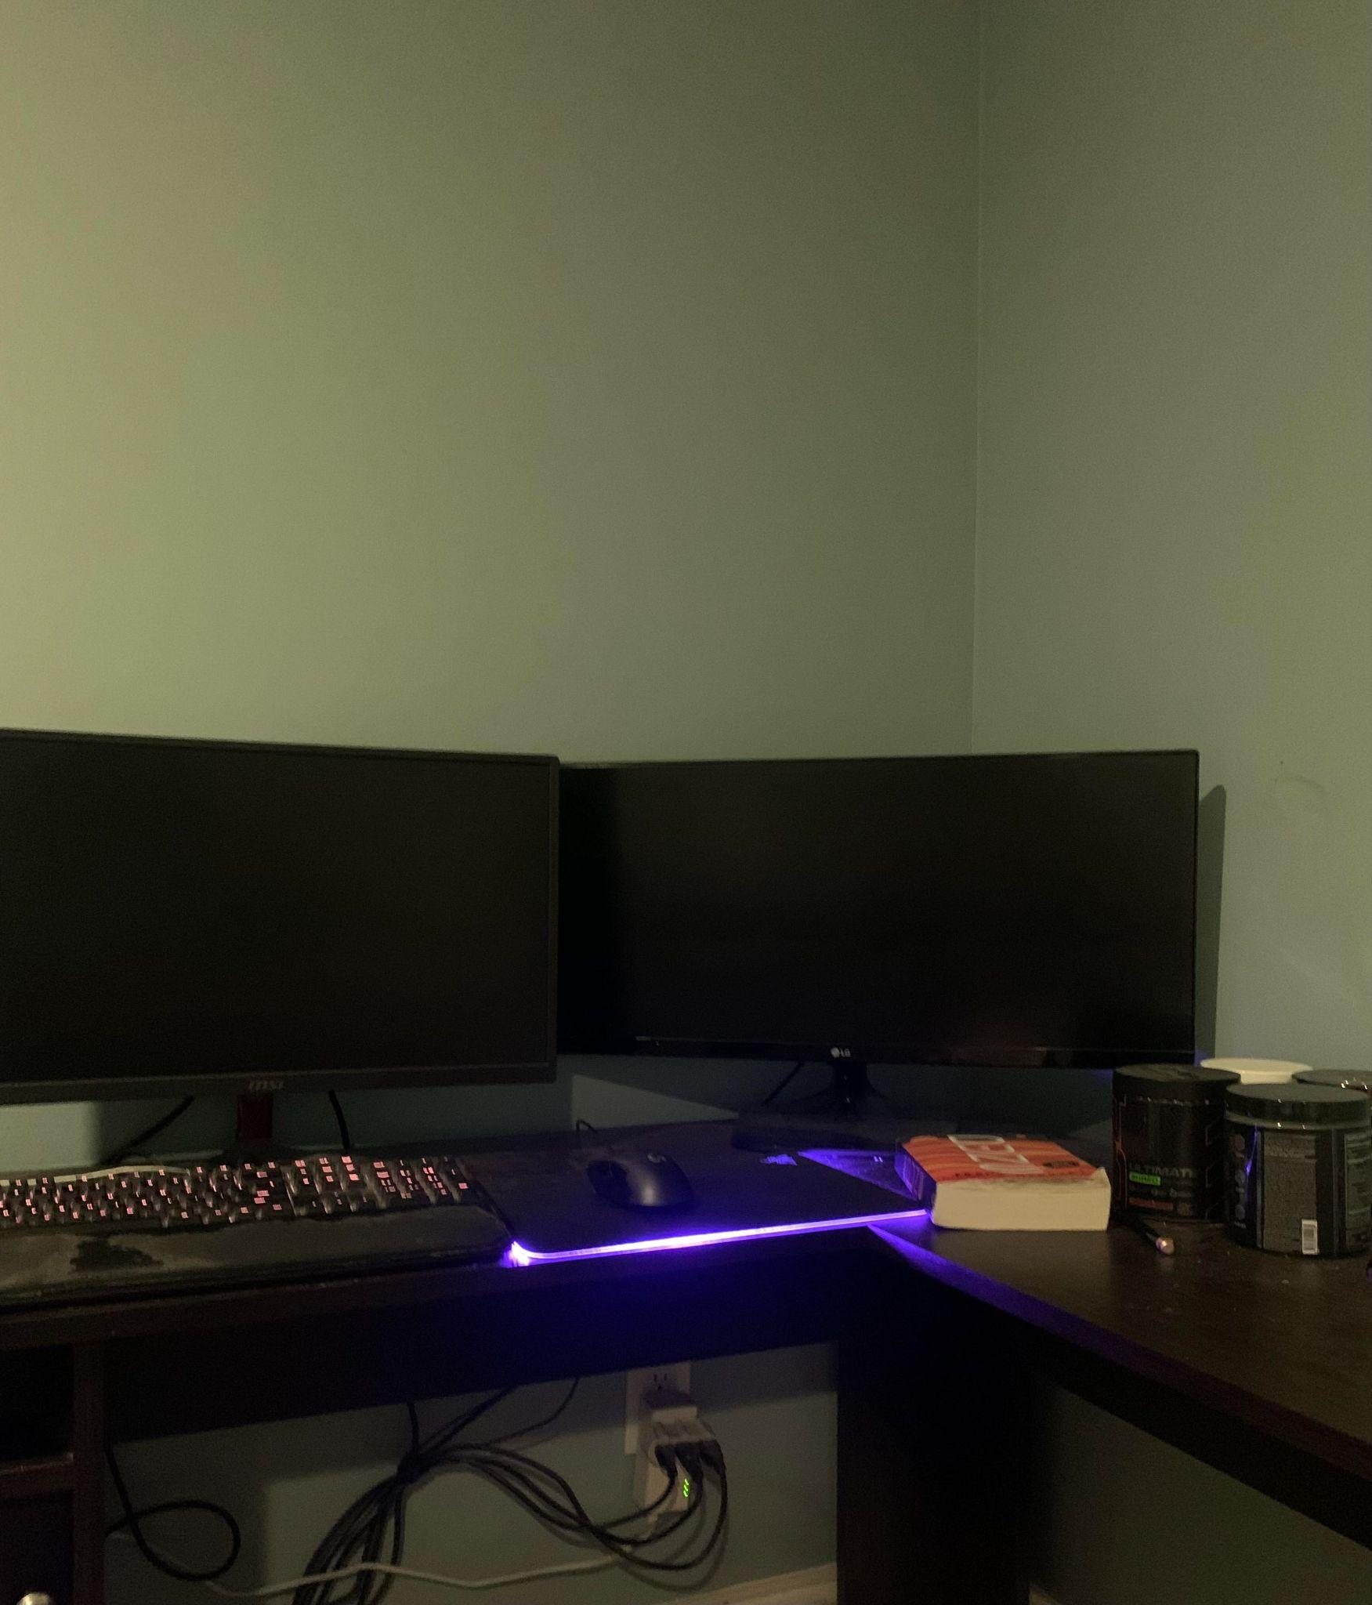

With all of that being said, I do have 0 experience using OpenGL and this may be too difficult of a task to accomplish. If Professor Battersby believes this object is beyond my skills, I can do another picture of my desk and recreate those objects. Being much, much easier, the monitors could be cubes, the preworkout tubs can be cylinders. The book can be recreated with a cube. The mouse can be a mixture of a sphere as well as tapered cylinders.